Space Shooter Game project Report

Prepared by
Latifur Rahman Zihad
Student id 180104
course code 3208

Under guidance of
Mostafijur Rahman Akhond
Computer Science and Engineering
Jashore University of Science and Technology

Introduction
This synopsis contains implementation of ‘Space shooter Game’ using a set of Opengl functions. The project consists of some activities. The intro Screen is the first screen. Then the second screen contains three options Start game, Instructions and Quit. The Start game screen shows the game scenario where two player can move up and down and rotate on their own ship and can fire laser to the opponent. The initial health of the both players are 100. When one of the player fire other player then if the laser hit the other player then it loose health. Here at last who can survive he won the game .To play this game we need to input from keyboard. The objects are drawn using GLUT library of C++.

Features

- The game consists of two players. Player 1 and Player 2. They have initial health 100.
- The players can move upward and downward.
- The players can rotate anti clockwise and clockwise with their ship.
- The both player can fire laser to the opponent to reduce his health.
- The one who survive at the end becomes the winner of the game.

Use Case Diagram
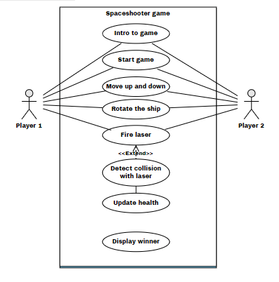

Implementation Details

Intro Screen
When we run the application firstly it popup the intro screen. It consists of information about programmer and the course teacher.

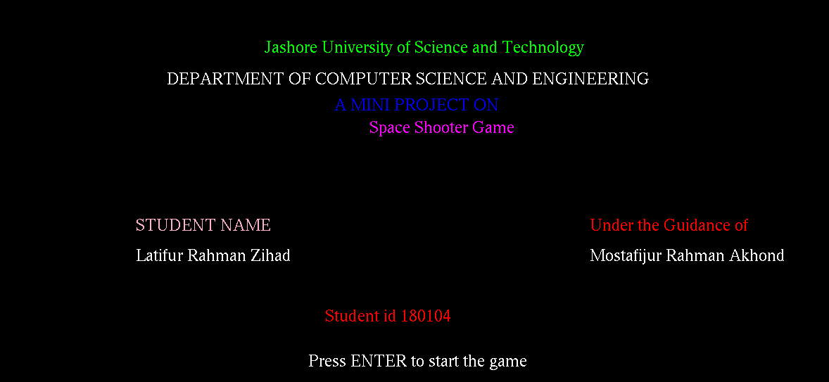

Start Screen
At the moment we press Enter on the intro screen then it shows start screen where we have three options Start Game,Instructions and Quit. we have to hover the mouse on these options to click them to go further.
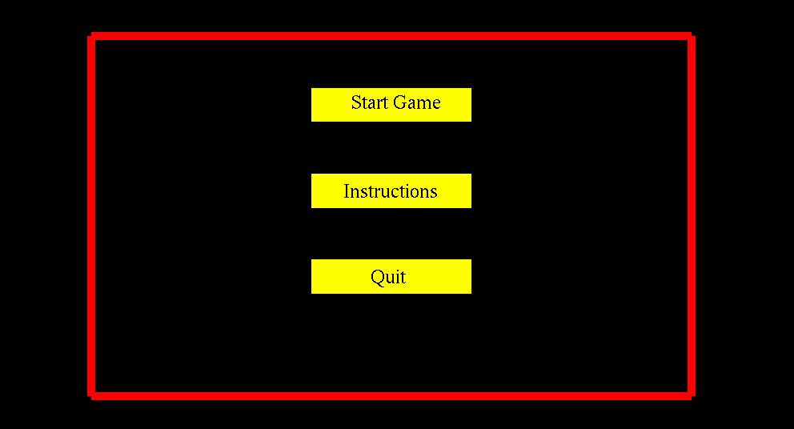
Instruction Screen
In this section the game instruction are there. This is the manual of the game.
It has rules of the game.
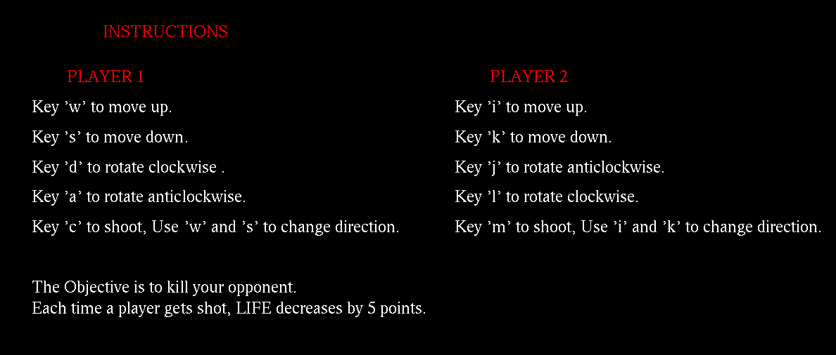
Game screen
This is the main game screen where the player plays the game. We have two player alien having space ship on space fighting each other by firing laser.
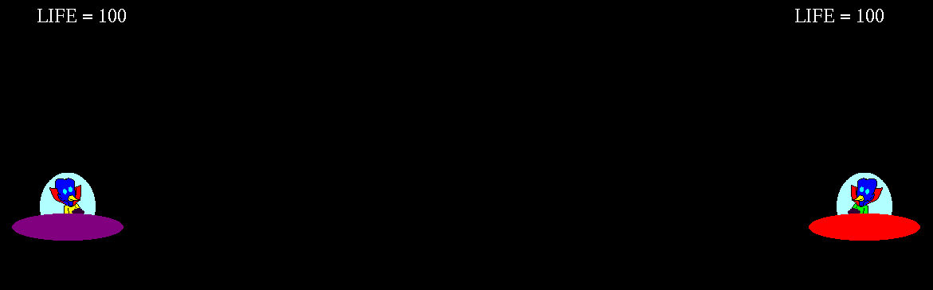
Game Over Screen
When the game end it shows the winner of that game and have two option start game and quit game.
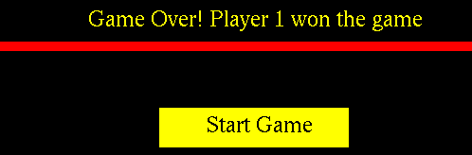

Acknowledgment
While writing an acknowledgment for this report firstly I have to mention my course teacher Mostafijur Rahman Akhond at most for his supports. When try to implement the code I have mention a youtube channel named “Networking pro” because of their explanation I figured out how to code in this project. I also acknowledge rajathpi for his open source code in github which helps a lot in implementing the project. One of my classmate helps me in making reports by his valuable advise. Thanks them all for my accomplishment of this project.

Conclusion and future plan
we have attempted to design and implement “Space shooter Game”.OpenGL supports enormous flexibility I design and the use of OpenGL graphics programs. The presence of many built-in classes methods take care of much functionality and reduce the job of coding as well as makes the implementation simpler. We have implemented the project making it user-friendly and error free as possible. We regret any errors that may have inadvertently crept in.

